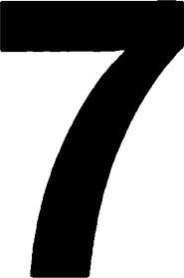

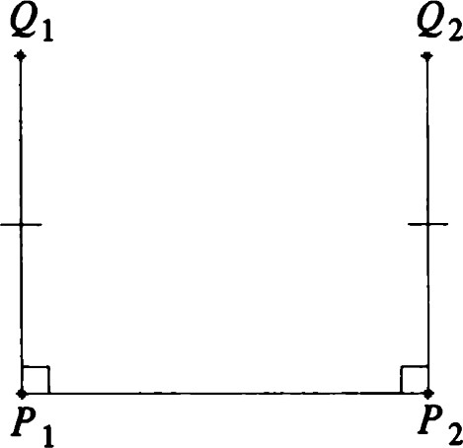

Figure 7.1 In hyperbolic geometry, d(Ql, Q2) > d(Pl, P2).

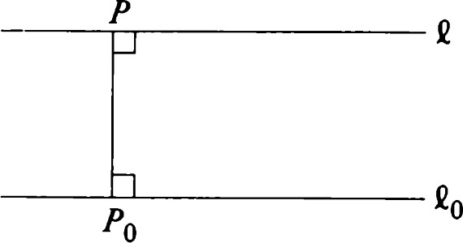

Figure 7.2 In hyperbolic geometry, eo and e do not meet.

The hyperbolic plane

# Introduction

The projective plane provides one alternative to Euclidean geometry. A second alternative is explored in this chapter.

The three geometries are contrasted in the following example: Take a segment PIP2 as shown in Figure 7.1. Erect equal segments PIQI and P2Q2 perpendicular to PIP2.

In E2 the segment QIQ2 will have length equal to that of PIP2. However, in P2 , the length of QIQ2 will be less than that of PIP2. In H2 we shall see that QIQ2 will be longer than PIP2.

This construction is also related to the question of parallelism. Let Co be a line, and let P be a point not on Co. Drop a perpendicular PPO from P to Co, and let C be the line through P perpendicular to PPO. (See Figure 7.2.)

In E2 , e will be parallel to Co. In P2 , e will meet Co. In H2 it will turn out that C does not meet Co.

We will now proceed to construct the geometry H2 . It will again consist of "points" and "lines" with a "distance" function defined for each pair of points. As in the case of E2 and P2 , we find that isometries of H2 are generated by reflections and satisfy the three reflections theorems.

# Algebraic preliminaries

Our model of spherical geometry was a certain subset of R3 , and the usual inner product of R3 played an important role. Our model of hyperbolic geometry will also be a subset of R3 . However, the bilinear form on which hyperbolic geometry is based is defined by

b (x , y) = X IYI + X2Y2 - X3Y3

(see also Chapter 6). A function of this type is used in Einstein's special theory of relativity. (See Frankel [151 or Taylor—Wheeler [291.) This explains some of the terms used in discussing its properties.

## Definition. A nonzero vector v e R3 is said to be Algebraic preliminaries

i. spacelike if b(v, v) > O. Ifb(v, v) = 1, it is a unit spacelike vector. An example is El. ii. timelike if b(v, v) < 0. Ifb(v, v) = —1, it is a unit timelike vector. An example is €3.

iii. lightlike if b(v, v) = O. An example is El €3.

We use the notation for the "length" of a vector v (i.e., lb(v, v)11/2). Unit vectors satisfy

In this chapter we use the term "orthonormal" to mean orthonormal with respect to b. Note that {El, €2, €3} is orthonormal.

Theorem 1.

i. Every orthonormal set of three vectors is a basis for R3 ii. Every orthonormal basis has two spacelike vectors and one timelike vector.

iii. For every orthonormal pair {u, v} of vectors, {u, v, u x v} is an orthonormal basis. (The cross product is taken with respect to b.) iv. For every unit spacelike or unit timelike vector v, there is an orthonormal basis containing v.

Proof:

i. We need only show that an orthonorn{al set is linearly independent. If an equation of the form

0 = Xlel + X2e2 +

holds, where {el, e2, e3} is orthonormal, then for each i,

0 = b(O, q) = Xib(q, ei)

implies that — ii. First note that all three vectors cannot be spacelike. In fact, if all b(ei, q) are equal and

3

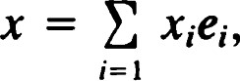

we have

3

b(x, x) = x2ab@i, q).

This would imply that all vectors are spacelike. Similarly, if all the ei were timelike, every vector in R3 would be timelike. We conclude that any orthonormal basis has at least one spacelike vector and one timelike vector.

Let {el, e2, e3} be an orthonormal basis. Suppose that el is spacelike

and e3 is timelike. Then (el x e3) x e2 = O, so that e2 is a multiple of el x e3. Further, b(el x e3, el x e3) = —b(el, el) b(e3, e3)

so that el x e3 (and hence Q) is spacelike. iii. We note that b(u x v, u x v) = —b(u, u) b(v, v) +1

and, hence, {u, v, u x v} is orthonormal.

iv. Suppose that v is spacelike. Let w be any unit timelike vector (e.g., = (O, O, 1)). If b(v, w) = 0, we can use {v, w, v x w} as our basis.

If not, choose ü = v + Xw, where X = -l/b(v, w). Then

b(ü, ü) = I + 2Åb(V, w)

If we set u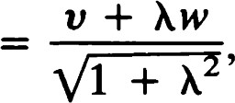

then {u, v, u x v} is an orthonormal basis.

Suppose now that v is timelike. A similar construction, using a unit spacelike vector w, leads to an orthonormal basis {u, v, u x v} , where u = (v +  = l/b(v, w).

Theorem 2.

1. For any x € R3

3

x = b(x, eDb@i, ei)ei (7.1)

if {el, Q, e3} is an orthonormal basis.

1. Let v be a timelike vector. Suppose that w x v * O and b(v, w) = 0. Then w is spacelike.

The Cauchy—Schwarz inequality played an important role in E2 and S2 Here is the hyperbolic version.

Theorem 3. Let and be spacelike vectors in R3 such that x is timelike. Then

 (7.2)

Proof: Let P be a unit timelike vector in the direction [E x n]. As in the proof of Theorem 1.4, we consider the function



|  |  |
| --- | --- |
| Because bC + m, P) = O for all real values of t and P x (E + m) * O, Theorem 2 applies, and + til is spacelike. In other words, f(t) > O for all t and  b(E, pn)2 < b(E, q).  Remark: If we weaken the hypothesis to bC x q, x 'Q) O, the conclusion becomes | Algebraic preliminaries |



|  |  |
| --- | --- |
| However, equality can occur even if and are not proportional. (See | |
| Exercise 2.)  There is a similar result for timelike vectors.  Theorem 4. Let v and w be timelike vectors. Then |  |
| b(v, b(v, v)b(w, w)  Proof: By Theorem 2, v x w is spacelike or zero. Thus b(v X w, v X w) O.  In other words, b(v, v)b(w, w) — b(v, < O with equality holding if and only if v and w are proportional. | (7.3) |
| Corollary. If v and w are unit timelike vectors, then lb(v, | 1. The |
| "inner product" b(v, w) is positive if and only ifb(v, €3) and b(w, €3) have | |
| opposite signs. | |
| Proof: The first statement is immediate from the theorem. To prove the | |
| second, we introduce the following notation. Let v = (PI, P2, r) and | |
| w = (ql, q2, s). Consider p = (PI, P2) and q = (m, q2) as vectors in R2 | |
| Then | |
| b(v w rs. | |
| Because (pl + Iql)2 0 with equality if and only if p = q = O, we have | |
| Ip12 + Iq12 —21pllql. | |

Adding 1 + Ip121q12 to each side yields

(1  > (Ipllql - 1 )2 .

But Ip1 2 — r 2 = —1 and Iq1 2 — s 2 = —1, so that

## (Ipllql — l)2 RS2

Suppose now that r and s are both positive but b(v, w) is also positive. Then 1 + rs; that is, (p, q) — 1 rs. By the Cauchy—Schwarz inequality for R2 , we get

## Ipllql -

which is incompatible with (7.4). We conclude that b(v, w) must be negative when r and s are positive. The conclusion now follows from the linearity of the function b.

### Incidence geometry of H2

The hyperbolic plane H2 is defined as follows:

H2 = {x e R3 > O and b(x, x)

Thus, as a set, H2 is just the upper half of a hyperboloid of two sheets.

Definition. Let be a unit spacelike vector. Then  = {x e H2 1b(E, x) = 0}

is called the line with unit normal (or pole) E.

Remark: Like the situation in spherical geometry, a line of H2 is the intersection with H2 of a plane through the origin of R3 . Not all planes through the origin meet H2 . However, if is timelike, it can be completed to a basis orthonormal with respect to b (Theorem 1). In particular, there are points x e H2 such that b(E, x) = O. We will now proceed to a detailed study of lines in hyperbolic geometry.

Theorem 5. Let P and Q be distinct points of H2 . Then there is a unique line containing P and Q, which we denote by PQ.

Proof: Apply Theorem 2(ii) with v = P and w = P x Q. The triple product formula shows that P x (P x Q) * 0 and, hence, that P x Q is spacelike. Let be a unit vector in the direction [P x Q]. Then the line whose unit normal is must pass through P and Q. This is the only line through P and Q because the unit normal to any such line must be orthogonal to P and Q (with respect to b) and, hence, must be a multiple of P x Q.

Just as in spherical geometry, the cross product is used to find the point of intersection of a pair of lines. However, if and Tl are spacelike unit vectors, x need not be timelike, and therefore the lines may not intersect in H2 . In fact, all three possibilities for x can occur. This is Perpendicular lines what makes H2 a richer incidence geometry than any we have studied previously.

Definition. Let C and be two lines with respective unit normals and n.

We say that e and m are

i. intersecting lines if x is timelike, ii. parallel lines if x is lightlike, iii. ultraparallel lines if x is spacelike.

Theorem 6. Intersecting lines have exactly one point in common. This point is the unique point of H2 that is a multiple of x T).

Proof: Clearly, the point in question lies on both lines. If P is any other point that lies on both lines, then

= -b(P, + b(P, = O, so that P is a multiple of x as required.

Remark: Neither parallel nor ultraparallel lines intersect.

# Perpendicular lines

Definition. Two lines with unit normals and are said to be perpendicular if b(E, n) = O.

Theorem 7. If two lines are ultraparallel, there is a unique line 'Y that is perpendicular to both of them. Conversely, if two lines have a common perpendicular, they must be ultraparallel.

Proof: Let and be unit normals of two ultraparallel lines. Let C be the unit (spacelike) vector that is a multiple of x n. Then b(E, C) b(n, C) = (), so the line with unit normal is a common perpendicular to the two lines.

Conversely, if the two lines have a common perpendicular, its unit normal is a spacelike vector satisfying x (E x T)) = O and, thus, is a multiple of x n. This means that x is spacelike, and the lines are ultraparallel.

Theorem 8.

1. If e and are perpendicular lines of H2 , then e intersects m.
2. Let X be a point of H2 and e a line of H2 . Then there is a unique line through X perpendicular to C.

Proof:

1. Let and be unit normals to e and m, respectively. Then {E, q, x •q} is an orthonormal basis by Theorem 1. Hence, x is timelike.
2. Let be a unit normal to C. Let be a unit vector proportional to  x X. This is possible because x X, being a nonzero vector orthogonal to X, must be spacelike.

The line whose unit normal is clearly passes through X but is perpendicular to C. There is only one line with this property, because a unit normal to such a line must be orthogonal to and X and, therefore, a multiple of their cross product.

Definitlon. The point F where m intersects e is called the foot of the perpendicular from X to e (provided X is not on C).

Remark: In the next section we define distance between two points of H2 .

As in E2 we can use this to define

# d(x, e) = d(x, F),

where F is the foot of the perpendicular from X to e.

## Pencils

Definition. Let e and m be a pair of distinct lines with respective unit normals and n. Then the set of lines whose unit normals are orthogonal to x is called a pencil of lines. is called a pencil of intersecting lines, a pencil ofparallels, or a pencil of ultraparallels according to whether x is timelike, lightlike, or spacelike.

Remark: At the moment this definition may look somewhat strange. Clearly, if x is timelike, then lines with unit normal will be the lines passing through the point of intersection, as expected. If x is spacelike, the pencil will consist of all lines perpendicular to a certain line. However, it is not yet evident what the pencil looks like when x is lightlike. When we look at H2 as a subset of P2 , we will get a more concrete interpretation for x and the associated pencils.

Remark:

1. The set of all lines of H2 perpendicular to a certain line of H2 is a pencil of ultraparallels.
2. Any two lines of H2 determine a unique pencil.

## Distance in H2 Distance in 142

We parametrize lines of H2 much as we did in S2 . Let be an arbitrary point of H2 . Let el and e2 be vectors of R3 such that {el, e2, e3} is an orthonormal basis.

A typical point on the plane through the origin spanned by {el, e3} is

Xe3 + VI. This point is on H2 if and only if X > 0 and b(Xe3 + VI, + VI) that is,



2

Using Theorem 3F, we may call X = cosh t and = Sinh t. Then as t ranges through all real numbers, (cosh t)e3 + (Sinh t)el runs through all the points of the line. We define distance in such a way that t measures distance along the line.

Definition. For x, y in H2 define d(x, Y) —— cosh-l(—b(x, y)).

Remark: This definition is possible because b(x, y) —1, as was shown in the corollary to Theorem 4.

Theorem 9. Let a(t) = (cosh t)e3 + (Sinh t)el. Then a(t2)) =

Proof: Exercise 6.

Definition. If ti < t < t2, then a(t) is between a(tl) and a(t2).

Now that we have defined distance between two points in the hyperbolic plane, it is necessary to determine which of the properties of Euclidean distance carry over to the hyperbolic case. The following is immediate from the definition.

Theorem 10. If P and Q are points of H2 , then

1. d(P, Q) O.
2. d(P, Q) = O if and only if P = Q. iii. d(P, Q) = d(Q, P).

We now address ourselves to the triangle inequality. Our proof of the triangle inequality in the spherical case relied on the cross product operation of E3 . Here we use the hyperbolic cross product.

Theorem 11 (Triangle Inequality). Let P, Q, and R be points of H2. Then d(P, Q) + d(P, R) d(Q, R) with equality if and only if P, Q, R are collinear and P lies between Q and R.

Proof: If P, Q, and R are not collinear, then P x Q and R x Q will not be proportional. Thus, (P x Q) x (R x Q) = b(P x Q, R)Q is timelike. We may apply the hyperbolic Cauchy—Schwarz inequality (Theorem 3) to get

x Q, R x  x Q, P x x Q, R x Q). (7.5)

But

= -b(P, Q) + b(Q, Q)

= b(P, R) + b(Q, Q)

because b(Q, Q) = -1. Let d(Q, R) = p, d(P, R) = q, d(P, Q) = r.

Then cosh p = -b(Q, R), cosh r = —b(Q, P), cosh q

Thus,

Q, R x Q) = cosh p cosh r — cosh q.

Also

= -b(P, Q) + b(R, = —1 + cosh2 r = sinh2 r.

and, similarly, b(R x Q, R x Q) = sinh2 p. Equation (7.5) now becomes

(cosh p cosh r — cosh < sinh2 r sinh2 p.

Hence,

cosh p cosh r — cosh q Sinh r Sinh p, cosh q cosh(p — r),





This is what we wanted to prove. Now if p = q + r, we have equality in (7.5). From Theorem 3 this means that (P x Q) x (R x Q) is not timelike, and, hence, b(P x Q, R) = O; that is, R lies on PQ. The fact that P lies between Q and R can be deduced easily from Theorem 9 and is left as an exercise (Exercise 7).

Remark: The properties of the hyperbolic functions used in this section 1 58 may be found in Appendix F.

## Isometries of H2 Reflections

A map T: H2 H2 is called an isometry if for all X and Y in H2 ,

d(TX, TY) = d(X, Y).

As in the case of E2 S2 , and P2 , isometries preserve collinearity. Specifically, we have the following.

Theorem 12. Let T be an isometry ofH2 . Then three distinct points P, Q, and R of H2 are collinear if and only if TP, TQ, and TR are collinear.

Proof: Exercise 8.

### Reflections

Let a be a line of H2 with unit normal E. For x e R3 let

Oax = x — 2b(x, E)E.

Theorem 13.

1. oa2 = 1.
2. Oa is a bijection of R3 onto R3 iii. b(Oax, OaY) = b(x, y) for all x, y € R3 .

Proof:

### i. oaoax = - 2b(Oax,

= x - 2b(x, - 2b(x, + 4b(x,

ii. Follows easily from (i).

#### iii. b(Oax, 00') = b(x — 2b(x, E)E, y — 2b(y, E)E)

= b(x, Y) — 2b(x, y) — 2b(y, E)

+ 4b(X, Ob(y, 9b(E, = b(x, y)•

Corollary. For any line a of H2 and x e R3 , we have the following:

i. If x is timelike, so is Oax. ii. If x is lightlike, so is Oax. iii. If x is spacelike, so ts Oax.

1. If x is a unit vector, so is Oax.
2. If x e H2 , so is Oax.

Definition. Given a line a of H2 , the restriction of Oa to H2 is called the reflection in a.

Theorem 14. Every reflection is an isometry of H2

Proof: For X, Y e H2

|  |  |  |  |
| --- | --- | --- | --- |
| d(0ax, oaY) = |  |  | oaY)) |
| = |  |  | Y)) = d(x, Y). |

Theorem 15. Let ß be a line of H2 with unit normal T). Then

## oaß = {Xe H2 1b(X, oar,) = 0};

that is, if ß has unit normal T), then Oaß is a line with unit normal 00).

Proof: Let Y e Oaß. Then for some X e ß, Y = Oax and b(Y, oar,) = b(0ax, 00)) = b(x, n) = O.

Conversely, if b(X, 001) = 0, then b(OaX, n) = b(OaOaX, Oar)) = O. In other words, Oax e ß and X e Oaß. cj

Theorem 16.

i. Let x be a point of H2 . Then Oax = x if and only if x e a. ii. Let ß be a line ofH2 . Then Oaß = ß if and only if a = ß or a i ß.

Proof:

i. x — 2b(x, = x if and only if b(x, E) ii. Let ß = {x e H2 1b(x, T)) = O}, where b(n, n) = 1. Then Oaß = ß if and only if — 2b(Tl, = This holds if and only if b(n, E) or = The former means that a -L ß, and the latter means that

### Motions

As before, an isometry that is a product of reflections is called a motion. In addition to reflections we distinguish four special kinds of motions.

Let a and ß be lines of H2 . If and ß intersect in a point P of H2 , then OaOß is called a rotation about P.

If a and ß are parallel, then OaOß is called a parallel displacement. If a and ß are ultraparallel with common perpendicular e, then OaOß is called a translation along e.

A glide reflection in H2 is the product of reflection in a line e with a translation along e. The line e is called the axis of the glide reflection.

# Rotations

Let P be an arbitrary point of H2 . The set of rotations about P is denoted by ROT(P). We construct matrices representing each element of ROT(P)

and prove that ROT(P) is a group isomorphic to SO(2). Rotations

Choose an orthonormal basis {el, e2, e3} so that e3 = P. If a is a line through P, we can write a = {xlb(x

where

( —sin O)er + (cos 0)e2.

Then oael =— 2(—sin= (cos 20)e1 + (sin 20)e2, oae2 = e2 — (2 cos= (sin 20)e1 — (cos 20)e1,

Oae3 —

Thus, the matrix of Oa with respect to {el, e2, e3} is

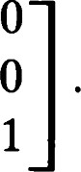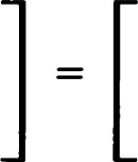 cos 20 sin 20 0

ref 0

sin 20 —cos 20 0

# o 10 0 1

Now, if ß is another line through P with pole

 = ( —sin (b)el + (cos +)e2,

then OaOß takes a similar form with 0 replaced by $. By the calculations of

Chapter 1, the matrix of OaOß is

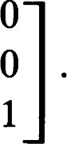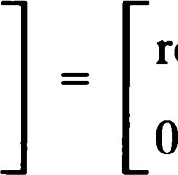cos — 4) —sin — (b) 0 sin — 4) cos 2(0 — 4) 0 rot — d))

1 

The function Oa -+ ref 0 determines an isomorphism of REF(P) (the group generated by reflections of H2 in lines through P) onto 0(2). Under this isomorphism ROT(P) goes into SO(2). Recalling the formulas of Chapter 1 (Theorems 33 and 34), we conclude the following:

Theorem 17 (Three reflections theorem). Let a, ß, and be lines through P in 1-12 . Then there is a fourth line through P such that = 06.

The related representation theorem for rotations holds.

Theorem 18. Let p be a rotation about P. Let e be a line through P. Then there exist lines and m' through P such that

p = oeo„ = 1 61

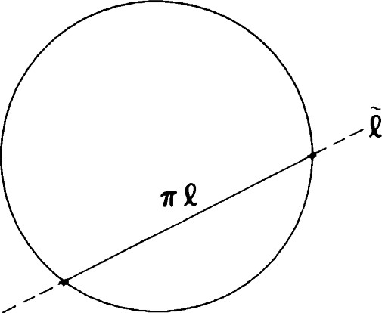

Figure 7.3 The Klein model. t n D2 represents a line of the hyperbolic plane.

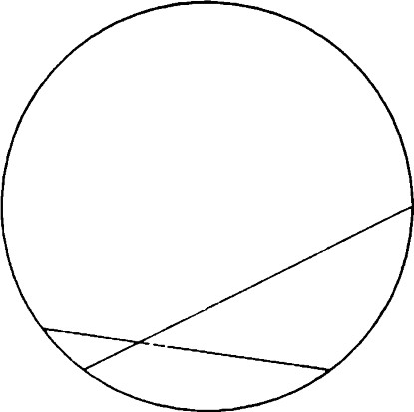

Figure 7.4 Intersecting lines.

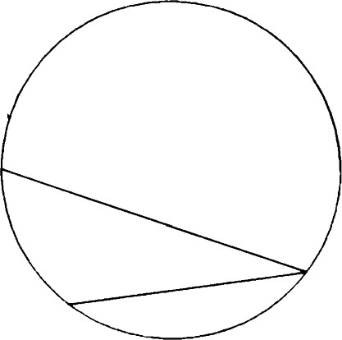

Figure 7.5 Parallel lines.

## H2 as a subset of P2

As well as being an interesting subject of study in its own right, the projective plane provides a framework in which other geometries can be embedded, often allowing an approach that facilitates both computation and understanding. In Chapter 5 we saw that it was possible to regard the incidence geometry of E2 as a subgeometry of P2 .

We now show that the hyperbolic plane can also be regarded as a subgeometry of P2 . Let D2 be the subset of P2 determined by the condition b(x, x) < 0. This set of points may be regarded as the interior of the conic b(x, x) = 0. We will call the remaining points of P2 (those with b(x, x) > 0) exterior points.

Theorem 19.

1. The usual projection q: R3 — {0} -4 P2 maps H2 bijectively to D2 .
2. For each point X ofP2 exterior to 1)2 , there is a unique pair {E, —E} of unit spacelike vectors such that = = X. Conversely, each unit spacelike vector determines such an exterior point.
3. A vector v e R3 is lightlike if and only if lies on the conic.

For most purposes we can look at D2 as the unit disk + x2 < 1 in the plane = 1 of E3 and work in this model of E2 rather than in P2 . We use the correspondence defined in Chapter 5, which relates E2 and P2 — em. In terms of homogeneous coordinates, is the line x3

Theorem 20. In terms of the model described in Theorem 19, if e is a line of H2 then is a chord of the disk 1)2 . The end points of the chord are, of course, not included in D2 nor in ITC. (See Figure 7.3.)

Remark: If e is a line of H2 , then is contained in a unique line t of P2 On the other hand, not all lines of P2 determine lines of H2 ; only those that are secants of the conic.

Theorem 21. Let and be lines of H2 . Then

i. and are intersecting lines if and only if Cl and intersect in D 2.

(See Figure 7.4.) ii. and are parallel if and only if Cl and intersect at a point on the boundary of D2. (See Figure 7.5.) iii. and are ultraparallel if and only if and intersect at a point exterior to 1)2 . (See Figure 7.6.)

Theorem 22. Two lines and are perpendicular if and only if El and are conjugate.

Theorem 23. Let C be a line of H2 . Let P and Q be points of P2 where meets the conic. Then the pole of is the intersection R of the respective tangents through P and Q.

Corollary. A line m of H2 is perpendicular to e if and only if passes through R, the pole of C. Figure 7.7 illustrates this and the previous two theorems.

Theorem 24. Each point ofP2 determines a unique pencil ofH2 as follows:

i. Each point = P of D2 determines the pencil of intersecting lines through x e H2 ii. Each point = P (where v is lightlike) determines a pencil of parallels.

iii. Each point = P (where is a unit spacelike vector) determines a pencil of ultraparallels. The common perpendicular to this pencil corresponds to the polar line of P.

In each case the pencil consists of all lines e of H2 such that passes through the designated point P of P2 .

Remark: The pictures in Figures 7.8—7.10 give an intuitive idea of these relationships.

The discussion of this section should provide a motivation for some of the constructions we have been making in hyperbolic geometry. The incidence geometry of D2 is precisely that of H2 , and this model of H2 is called the Klein model. Unfortunately, the Klein model does not represent either distance or angle faithfully, so it is unwise to rely too heavily on it. For example, a line is infinitely long, although it is represented in D2 by a (finite) chord.

### Parallel displacements

Let be a pencil of parallels determined by two lines with unit normals  and T). Choose an orthonormal basis by setting el — E, e3 e H2 , and e2 = e3 x el. If we write

 = kel + pe2 + ve3, with k 0

the conditions that b(n, n) = 1 and that x is lightlike give p ± v and k = 1. Hence,

 = el + p(e2 ± e3).

### Parallel displacements

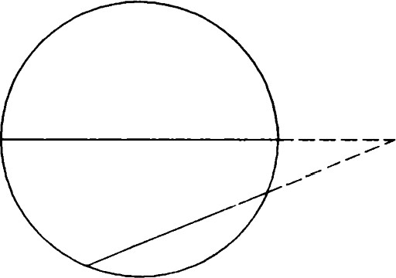

Figure 7.6 Ultraparallel lines.

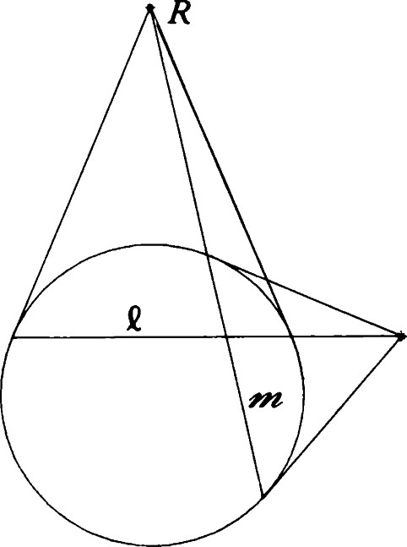

Figure 7.7 Two perpendicular lines, e and m.

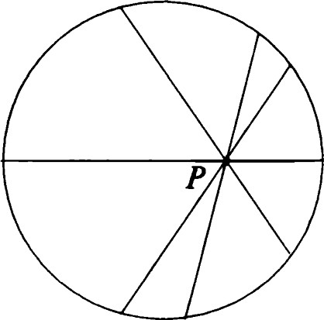

Figure 7.8 A pencil of intersecting lines.

## 1 63

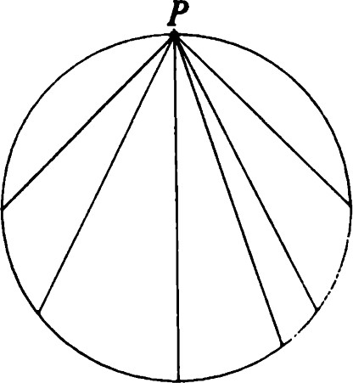

Figure 7.9 A pencil of parallels.

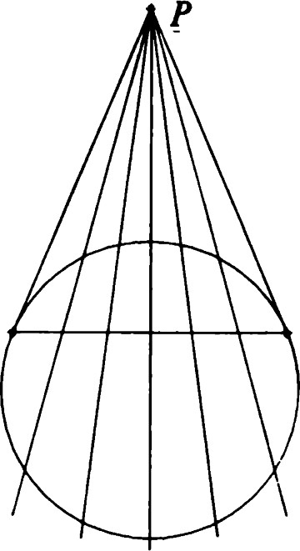

Figure 7.10 A pencil of ultraparallels.

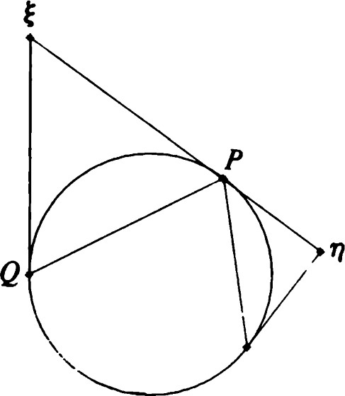

Figure 7.11 Two lines of a parallel pencil.

Theorem 25. In terms of the basis just described, suppose that contains lines with unit normals (1, 0, 0) and (1, p, —p) for some real number p. Then consists precisely of those lines with unit normals of the form (1, r, —r), where r ranges through the real numbers.

Proof: First note that  x = p(el x e2 — el X e3) = —p(e3 so that x is lightlike. Furthermore, if— e3), then

b(C, x -n) = prb(e2 — 

Conversely, if t, is a unit spacelike vector orthogonal to x T), it is easy to check that must be of the form (1, r, —r).

Remark: The projective model of H2 provides some insight into what is going on here. The self-conjugate point P of P2 through which all lines of the pencil pass is (0, 1, —1). A typical line of the pencil has its pole on the tangent to the conic at P. (See Figure 7.11.)

Note that a line of H2 belongs to two distinct pencils. In our example there is a second pencil through Q = (0, 1, 1). The same basis may be used, but in this case the unit normals of lines of the pencil are (1, r, r).

We have shown that a pencil of parallels is parametrized by the set of real numbers. Let a be a line of the pencil with pole (1, r, —r) in homogeneous coordinates. Then el - 2b(E, = —el — 2re2 + 2re3, e2 — 2r(e1 + re2 — rej = —2rel + (l — 2r 2)e2 + 2r 2e3, Oae3 — — 2r(e1 rej = —2re1 — 2r 2e2 + (l + 2r 2)e3.

The matrix of Oa is

2r2(7.6)

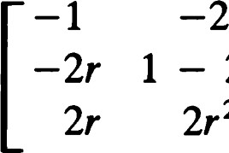

2r2

I + 2r 2

If ß is a second line of this pencil, a calculation shows that

### oa0ß = -2h 1 - 2h2 -2h2(7.7) 2h2 I + 2h2

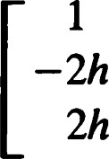

1

where ß has pole (1, s, —s) and h = s — r. Thus, the parallel displacement OaOß is represented with respect to this basis by the matrix Dh of (7.7). One can check that for real numbers h and k, DhDk = Dh+k.

|  |  |
| --- | --- |
| Theorem 26 (Three reflections theorem). Let a, ß, and be lines in a pencil of parallels. Then there is a fourth line b in the pencil such that | Translations |



|  |  |
| --- | --- |
| Proof: With respect to an appropriate basis of R3 , there exist real numbers r, s, and t representing a, ß, and py in the sense that (1, r, —r) is a unit normal to a, and so forth. Now  = 06 iff   = oaoo;  that is,  Dt_s = Du _ r,  where u is the real number representing b. If we choose u = r + t — s, this last equation becomes true. Hence, the theorem is true, and the pole of the required line 8 is represented by el + (r + t  A representation theorem for parallel displacements holds also.  Theorem 27. Let p be a parallel displacement arising from a pencil g. Let e be a line of". Then there are lines m and m' in such that p = oeo„ =  Proof: Exercise 18.  Let REF(") be the group generated by all reflections in lines of the pencil 9. Let DIS(") be the set of all parallel displacements determined by the pencil 9. In Exercise 19 you will show that DIS(") is a group and investigate its algebraic properties.  Translations  Let be an ultraparallel pencil with common perpendicular C. Let el be a unit normal of e. Choose e2 and e3 spacelike and timelike, respectively, so that {el, e2, e3} is an orthonormal basis.  Let a be an arbitrary line of the pencil. Its unit normal can be written  — (cosh u)e2 + (Sinh u)e3.  Then oael = el - 2b@l, = el,  082 — e2 — (2 cosh u)((cosh u)e2 + (Sinh u)e3) |  |
| = —(cosh 2u)e2 — (Sinh 2u)e3, | 1 65 |

= (Sinh 2u)e2 + (cosh 2u)e3.

1 o —cosh 2u Sinh 2u  (7.8) o —sinh 2u cosh 2u

If ß is a second line of the pencil whose pole is parametrized by v, then

1 oa0ß = 0 cosh 2k Sinh 2k(7.9) 0 Sinh 2k cosh 2k

where k = u — v.

Denote this last matrix by Tk. Then one can easily verify that

TkTm = Tk+m.

Theorem 28 (Three reflections theorem). Let a, ß, and be lines of a pencil of ultraparallels. Then there is a line 8 in the pencil such that

= 06.

Proof: Exercise 21.

Theorem 29 (Representation of translations). Let p be a translation along a line e. Let be any line perpendicular to e. Then there exist lines a and a' perpendicular to e such that

### p = o„oa =

Let be a pencil of ultraparallels, and let e be the common perpendicular. The group generated by all reflections in lines of is denoted by REF("). Let TRANS(C) be the set of translations along e. Properties of TRANS(C) will be left to the exercises (Exercise 22).

#### Glide reflections

With respect to the basis used in the previous section, we construct the matrix of the glide reflection OeTk. One can easily check that

= —el, Oee2 — e2, oee3

Thus,

-1 oeTk = 0 cosh 2k Sinh 2k  (7.10)

1 66 0 Sinh 2k cosh 2k

#### Products of more than three reflections

In each of the geometries studied so far, any motion can be realized as the product of two or three reflections. The same is true in H2 . However, the incidence structure of H2 is more complicated. More cases must be considered in the proof.

Our approach is to show that any product OaOßChOb of four reflections can be reduced to a product of two reflections (as in Theorem 1.36). As a first observation, if the pencil determined by a and ß has a line in common with the pencil determined by and 6, our representation theorems may be applied to rewrite our product of four reflections in such a way that the second and third reflections are the same.

We begin with

Theorem 30. Let P be a point ofH2 , and let be a pencil. Then there is a line through P belonging to the pencil 9. Except in the case of the pencil of all lines through P, this line is unique.

Proof: If is a pencil of intersecting lines or a pencil of ultraparallels, the conclusion is given by Theorem 4 and Theorem 8, part (ii), respectively. Now let be a pencil of parallels determined by lines with unit normal and q. Then x is lightlike, and P x (E x n) is nonzero. By Theorem 2, part (ii), P x (E x n) is spacelike. The line whose unit normal is in this direction belongs to and passes through P and is the only line satisfying these conditions.

Theorem 31. Let 91 be a pencil of parallels. Let 92 be the pencil consisting of all lines perpendicular to a line -y. If 91, there is a unique line belonging to both pencils.

Proof: Choose an orthonormal basis as follows. Let e2 be a unit normal to -y. Let w be a lightlike vector such that the unit normals to lines of 91 are precisely those unit spacelike vectors satisfying b(E, w) = O. See Figure 7.12.

We wish to choose e3 e H2 so that it lies in [w, e21. To do this, note that

b(w x e2, w x e2) = b(w, e2)2 > O

because -y 91. Choose el to be a unit vector in the direction [w x e2], and e3 = el x e2. There are two choices for el, but only one that will ensure that e3 lies in H 2.

Now that we have this basis, it is easy to see that the line with unit normal el is the unique line belonging to both pencils.

##### Products of more than three reflections

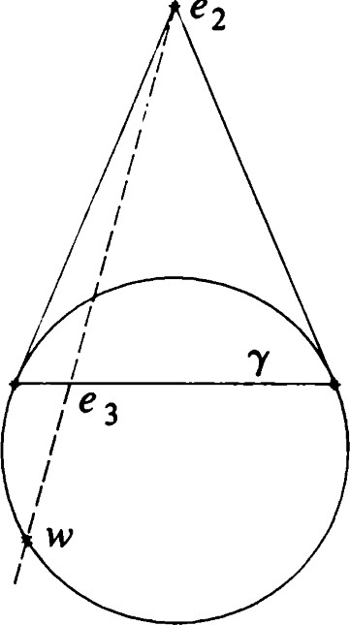

e2

Figure 7.12 Construction of a line common to a parallel pencil and an ultraparallel pencil.

## 1 67

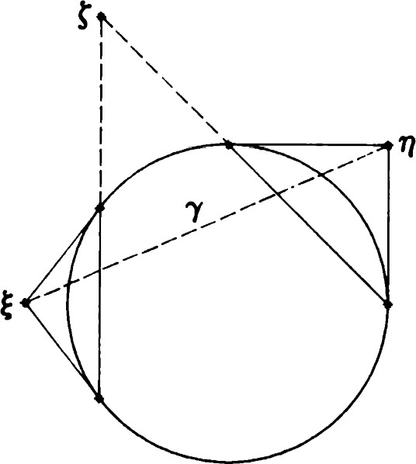

Figure 7.13 Theorem 7. Two ultraparallel pencils with a common line -y.

## 1 68

Remark: If the two pencils are related in such a way that -y e 91, then they can have no line in common. (See Exercise 33.)

Theorem 32. Two distinct pencils of parallels have a unique line in common.

Proof: Let v and w be lightlike vectors determining distinct pencils. Then

Theorem 5.26 gives

### b(v x w, v x w) = b(v, w)2 ,

which is positive (Exercise 34). The line whose unit normal is a multiple of v x w is the unique line common to both pencils.

Remark: Two ultraparallel pencils have a line in common if and only if the common perpendiculars to the two pencils are themselves ultraparallel. See Figure 7.13 and Theorem 7. Thus, we have completed our analysis of the question of when two pencils have a line in common. We now have enough ammunition to attempt the task set out at the beginning of this section.

Theorem 33. Let a, ß, y, and be lines. Then there exist lines u and v such that

o o o o = ouov.

Proof: If a = ß or = b, there is nothing to prove. Assume that a and ß determine a pencil 91, whereas py and determine a pencil 92. As remarked at the beginning of this section, the result clearly holds if and  have a line in common. In view of Theorems 30—32, we have still to consider the following cases:

1. a and ß have as a common perpendicular, and is parallel to •y. In this case 0B commutes with O.y, and Theorem 30 applies.
2. a and ß have a common perpendicular e, -y and have a common perpendicular m, and e intersects m in a point P. Using Theorem 29, we may replace the given representation by  where ß' and -y' pass through P. Then Og,Ch, may be replaced by O(Oh for some line n through P. Because a' is perpendicular to C, Theorem 30 now applies.
3. a and ß have a common perpendicular C, •y and have a common perpendicular m, but e is parallel to m. In this case we let Q be the point where m intersects •y, and we let ß' be the line through Q perpendicular to e. Then the motion can be written  for some line a' i e. As in case (2) we may now write

= onom for some line n. Again apply Theorem 30.

Remark: Because Fixed lines of isometries

## —1 = 0000

the foregoing set of cases is exhaustive. For example, it is not necessary to consider the case where a and ß are parallel while -y and 8 have a common perpendicular.

Theorem 34. Let a, ß, and -y be lines not belonging to any pencil. Then OaOßOY is a nontrivial glide reflection.

The proof of Theorem 34 uses techniques similar to those we have been using in Theorem 33. It is left as an exercise (Exercise 35).

We can now assert the following classification of motions of H2

Theorem 35. The group of motions of H2 consists of all reflections, rotations, translations, parallel displacements, and glide reflections. Every motion is the product of two or three suitably chosen reflections.

### Fixed points of isometries

Consider the isometry p = OaOß. Fixed points of p are found by solving for X e H2 the equation PX = X; that is, Oax = OßX. Any solution must satisfy b(X, = b(X, TI)TI. If b(X, E) = b(X, n) = O, then X is a multiple of x T). This means that X is the point of intersection of and ß in H2 . On the other hand, if b(X, E) * 0 or b(X, T)) * 0, must be a multiple of n, and so a = ß. Thus, we can state

Theorem 36.

1. A nontrivial translation has no fixed points.
2. A nontrivial rotation has exactly one fixed point, the center of rotation. iii. A nontrivial parallel displacement has no fixed points.
3. A reflection has a line of fixed points, the axis of reflection.
4. A nontrivial glide reflection has no fixed points.

This result may be compared with the Euclidean analogue, Theorem

1.39. For the proof see Exercise 37.

#### Fixed lines of isometries

If Oa is a reflection whose axis has unit normal E, then Oa will leave fixed the lines whose unit normals satisfy Oat, = that is, must be orthogonal to or t, =

Suppose now that a and ß are lines with respective unit normals  1 69 and q. Then p — OaOß has a fixed line with unit normal if and only if OaC = ±OßC. The condition = —C)ßC is satisfied only if t,

#### n)Tl. But this implies that b(c, = b(c, 9bC, E) + b(c, E)

and

b(C, T)) = b(C, 9b(C, n) + b(C, q).

These equations in turn give b(c,  = b(C, E) = 0.

Thus, either a -L ß or b(C, m) = b(C, E) = 0, which would imply = 0, an impossibility.

We conclude that = —OßC if and only if a L ß and is in the span of  and n. This means that p is a half-turn, and the fixed line passes through its center.

We now search for t, with b(C, C) = 1 and = 0ßC. Then b(c, = b(C, q)n. If a * ß, this implies that b(C, = b(C, n) = O. Thus, the line of H2 with unit normal t, is a common perpendicular of a and ß.

Summarizing our results concerning isometries that are the product of two reflections, we have

Theorem 37. Let a and ß be distinct lines ofH2 . The isometry OaOß has the following fixed line behavior.

1. If a and ß intersect at P and a L ß, every line through P is fixed. In this case, OaOß is the half-turn about P.
2. If a and ß intersect at P and a is not perpendicular to ß, OaOß has no fixed lines.
3. If a and ß are parallel, OaOß has no fixed lines. Thus, parallel displacements have no fixed lines.
4. If a and ß have a common perpendicular e, then OaOß leaves e fixed but has no other fixed lines.

Theorem 38. Let -y be a line perpendicular to two distinct lines a and ß. Then the nontrivial glide reflection has •y as its only fixed line.

Proof: We must determine the unit spacelike vectors t, satisfying oac =

A calculation similar to that used in Theorem 37 shows that the positive sign cannot occur. With the negative sign t, must be a unit normal to the

1 70 line •y. The details are left to Exercise 38.

### Segments, rays, angles, and triangles Segments, rays, angles, and triangles

Let P be a point. As we know, a line through P can be parametrized by

a(t) = (cosh t)P + (Sinh

for a suitable unit spacelike vector E. A set of the form a([O, L]), L > O, is called a segment of length L. The points a(O) and a(L) are called end points. The point M = a(L/2) is the midpoint, and the usual definition of perpendicular bisector holds. The set 00 )) is called a ray. The point a(O) is called the origin of the ray. It is a not-quite-obvious fact that these definitions have all the properties we should expect.

Theorem 39.

1. Two distinct points A and B are the end points of exactly one segment, which we denote by AB or, equivalently, BA. The length of AB is
2. Each ray has exactly one origin. For each pair ofpoints A and B, there is exactly one ray with origin A that passes through B. We denote this ray by AB.

Definition. The unit spacelike vector occurring in the definition of a is called the direction vector of the ray a )). Note that b(P, E) = 0.

Remark: Each ray has a unique direction vector. Taking our inspiration from the projective model of H2 , we may think of as a point "past infinity" toward which the ray is heading.

Angles and triangles are defined as in E2 along with the associated terms (straight angles, opposite rays, etc.). The radian measure of an angle is cos -l b(E, m), where and T) are the direction vectors of the rays making up the angle. In Exercise 41 you will be asked to check that this is equivalent to

Q X P Q x R

#### cos -l b

IQ x PI' IQ x RI

for the angle 4PQR. Note that Q x P and Q x R are spacelike vectors.

Definition. A half-plane bounded by a line e is a set of the form

{x e H2 1b(E, x) > O},

where is a unit normal of e.

Theorem 40. Each half-plane is bounded by a unique line. Each line bounds two half-planes. The union of these two half-planes is H2 - e. Two points ofH2 — e are in the same half-plane if and only if the segment joining them does not meet e.

Definition. The interior of an angle 4 PQR is the intersection of the half-plane bounded by PQ containing R with the half-plane bounded by RQ containing P. (This definition does not make sense for straight angles or zero angles. The interior of such an angle is undefined.)

Theorem 41. Let = 4 PQR be an angle whose interior is defined. Let  and be direction vectors of its arms. Then the interior of consists of those points X such that the direction vector of QX is a positive linear combination of and T).

Proof: Let X be any point other than Q, and let r, be the direction vector of QX. Because the subspace {v e R3 lb(v, Q) = O} is two dimensional, {E, is a basis, and there are unique numbers k and such that  = + pro.

We claim that X is in the interior of Jif and only if k and are positive. To see this, write

X = (cosh t)Q + (Sinh

and note that x Q is a unit normal to one arm, say QP. Then

b(X, x Q) = (Sinh x Q) = p(sinh x Q)

Sinh t

#### ——b(R, x Q),

Sinh s

where s is the number satisfying R = (cosh s)Q + (Sinh s)n. Thus, X and R lie on the same side of PQ if and only if p > O. Similarly, X and P lie on the same side of RQ if and only if k > 0.

##### Addition of angles

Theorem 42.

1. Let = 4 PQR be an angle with a point X in its interior. Then the radian measure of is the sum of the radian measures of 4 PQX and 4RQX.
2. Let = 4 PQR be a straight angle, and let X be any point not on the line PQ. Then the sum of the radian measures of 4 PQX and 4 RQX is

1 72 equal to q.

Proof: Triangles and hyperbolic i. Let E, q, and be the respective direction vectors as in Theorem 41. trigonometry We need to prove the identity cos -l b(E, C) + cos -l b(C, n) = cos -l b(E, n), (7.11)

using the fact that = + pm, where k and p are positive numbers satisfying

 + p2 + 2kb.LbC, = 1.

For convenience write a = b(E, q). Then b(E, C) = k + pa and b(c, n) — ka + p, so that our identity reduces to cos -l (x + pa) + cos -l (ka + p) = cos -l a, (7.12)

which can be verified by calculus (Exercise 44).

ii. When 4 PQR is a straight angle, we have no expression for in terms of and n. We do not need one, however. The required identity reduces to cos -l b(E, C) + cos -l C) = q,

which is just one of the standard properties of the cos -l function. (See Theorem 2F.)

Remark: The Euclidean version of this theorem (Theorem 2.14) is essentially the same thing. We could have used the preceding proof in Chapter 2. On the other hand, if we fixed an orthonormal basis {el, e2, e3} for R3 with e3 = Q, the proof given in 2.34 can be easily modified to prove Theorem 42. Both proofs have advantages and disadvantages. The first one is more geometric. The second one is more direct but relies explicitly on a computation involving differentiation, and therefore it is in some sense less elementary.

Remark: All our Euclidean definitions of rectilinear figures and their associated properties hold true in H2 . Because of the incidence structure of H2 , however, some new types of figures are possible.

### Triangles and hyperbolic trigonometry

In hyperbolic geometry triangles are easier to deal with than in spherical or elliptic geometry because segments are simple. Each pair of points determines a unique segment. Thus, we can define, as in E'2 , the triangle APQR to be the union of the segments PQ, QR, and PR. Each triangle has three angles. The interior of the triangle is the intersection of the interiors of its three angles.

Theorem 43. Let ABC be a triangle. Let a, b, and c be the lengths of its sides. Then, using the same notational conventions as in spherical trigonometry (see Figure 7.14), we have

#### cosh b cosh c — cosh a

|  |
| --- |
| 2(sinh s sinh(s — a) sinh(s — b) sinh(s |

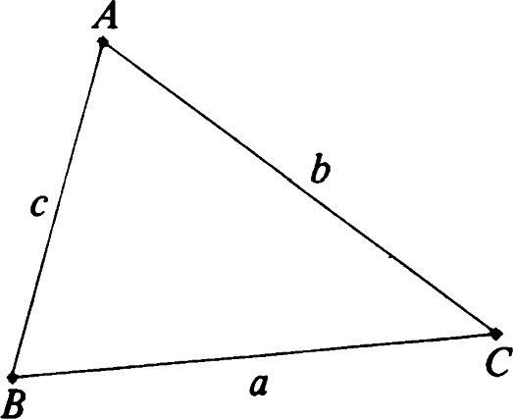i. cos A — (7.13) Sinh b Sinh c

#### sin A

ii.  (7 • 14)

Sinh a Sinh a Sinh b Sinh c

#### cos A + cos B cos C

iii. cosh a(7.15) sin B sin C

Remark: Birman and Nomizu [51 have worked out trigonometric formulas Figure 7.14 Theorem 43. A hyperbolic

triangle. for Lorentzian plane geometry. Their formulas bear a relationship to (7.13) and (7.14) analogous to that between plane Euclidean and spherical (Theorem 4.38) formulas, This is related to the fact that H2 may be regarded as a "sphere" in Lorentzian three-space. (See Exercise 72.)

#### Asymptotic triangles

Each line belongs to two parallel pencils. However, each ray determines a unique parallel pencil. In fact, if t, is the direction vector of a ray PX, then P + t, is a lightlike vector with the property that {Elb(E, P + C) = O} is the set of unit normal vectors of a unique pencil. (The other pencil to which the line PX belongs is determined by P — C.)

Let PQ be a segment, and let PX and QY be parallel rays determining the same pencil. Then the union of PQ and the two rays is called a (singly) asymptotic triangle. Two views of an asymptotic triangle are shown in Figure 7.15. You may think of an asymptotic triangle as an ordinary triangle with one vertex "at 00.'

A pair of rays PX and PY together with the line common to the parallel pencils they determine is a doubly asymptotic triangle. See Figure 7.16. A triply asymptotic triangle consists of three lines mutually parallel in pairs. See Figure 7.17.

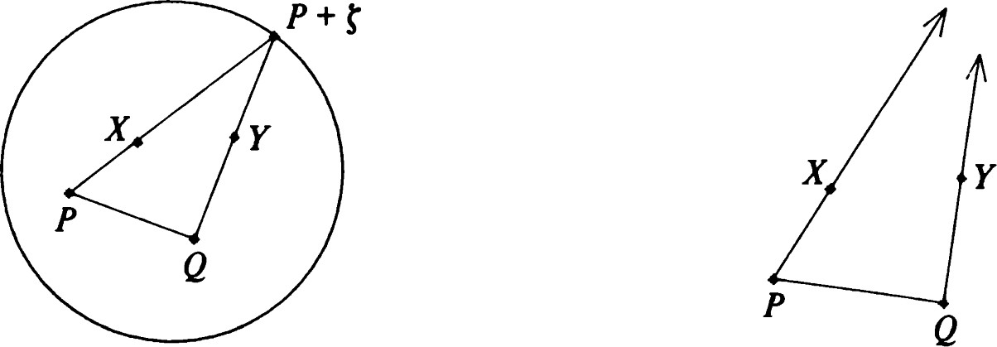

1 74 Figure 7.15 A singly asymptotic triangle, two views.

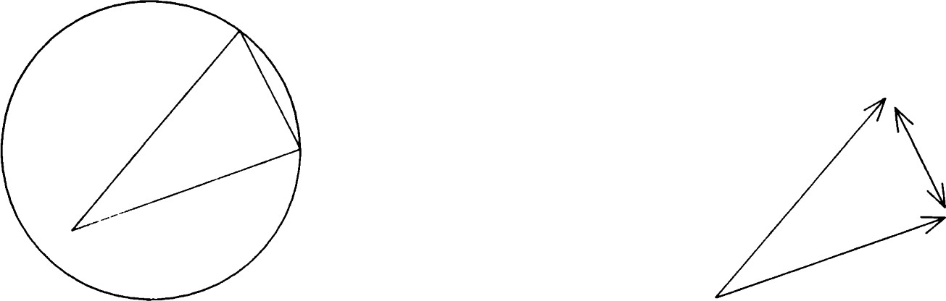

Figure 7.16 A doubly asymptotic triangle, two views.

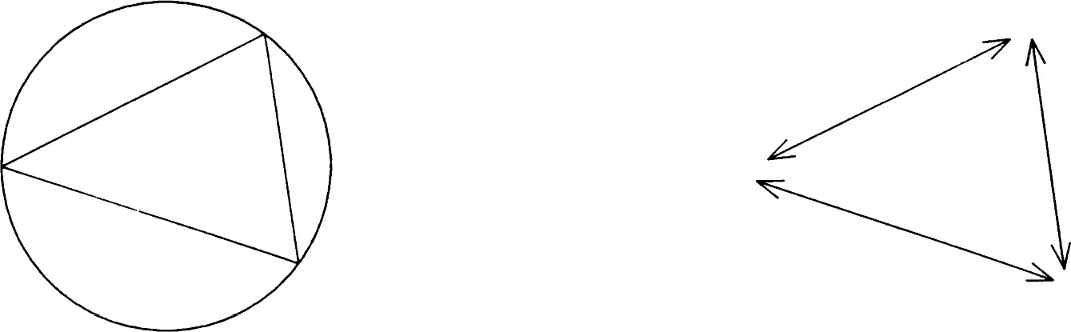

Figure 7.17 A triply asymptotic triangle, two views.

### Quadrilaterals

A convex quadrilateral ABCD is the union of four segments (sides) AB, BC, CD, and DA that are placed in such a way that each side determines a half-plane that contains the opposite side (See Figure 7.18.) Note that AC intersects BD at an interior point of the figure. The other diagonal points (in the sense of projective geometry) can be distributed in six distinct configurations as far as incidence is concerned. This together with the possibilities for equality of various lengths and angles gives us a rich variety of generalizations of the notions of parallelogram, rectangle, rhombus, and square. We will only scratch the surface of this wealth of symmetric figures.

First, consider a convex quadrilateral ABCD in which opposite sides have the same length. This is the best genpralization of the Euclidean notion of parallelogram. The special case in which all four sides have equal length is called a rhombus. (See Figure 7.19.)

A convex quadrilateral in which all four angles have equal radian measure is called an equiangular quadrilateral. The equiangular rhombus is the hyperbolic analogue of the square. (See Figures 7.20 and 7.21.)

Although convex quadrilaterals cannot have four right angles in hyperbolic geometry, there are several different figures that could be considered analogues of the rectangle. The Saccheri quadrilateral ABCD has d(A, B) = d(C, D), AB L BC, and CD BC. (See Figure 7.22.) The Lambert quadrilateral, on the other hand, has three right angles. It is shown in Figure 7.23.

#### Quadrilaterals

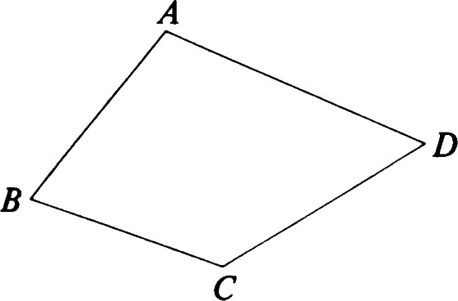

Figure 7.18 A convex quadrilateral.

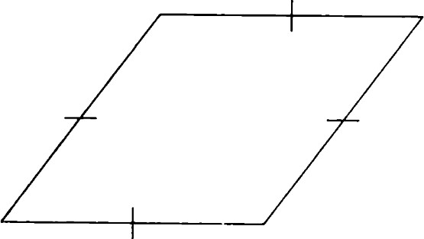

Figure 7.19 A rhombus.



Figure 7.20 An equiangular quadrilateral.

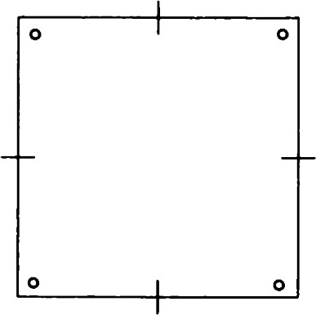

Figure 7.21 An equiangular rhombus.

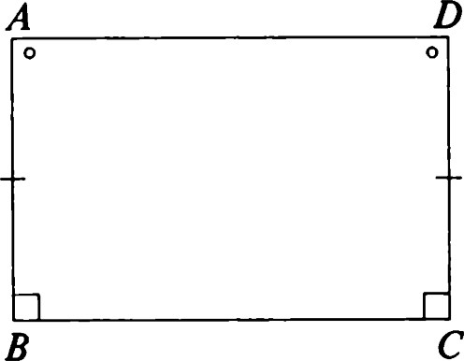

Figure 7.22 A Saccheri quadrilateral.

### 1 76

#### Regular polygons

A regular polygon with any number of sides can be constructed by taking as vertices the orbit of a point Q under a cyclic subgroup of the group of rotations leaving another point P fixed. The resulting figure has the same symmetry group as in the Euclidean case. However, as the trigonometric formulas show, the angles get smaller as d(P, Q) increases. In general, there are regular m-gons whose angles all have radian measure equal to any number between O and (1 — 2./m)1T that you wish to prescribe. For example, there is a regular 7-gon all of whose angles are right angles. See Figure 7.24.

#### Congruence theorems

Theorem 44. There is a unique reflection that interchanges a given pair of points of H2

Proof: Let P and Q be the given points. Let m be the perpendicular bisector of PQ. Note that the midpoint M of PQ is a unit timelike vector in the direction [P + QI and that the unit normal to has direction [P — Q]. It is a straightforward exercise (Exercise 51) to verify that 0m interchanges P and Q. On the other hand, if 0m, is any reflection interchanging P and Q, then OmO„, must leave P and Q fixed and, hence, by Theorem 36, must be the identity.

Theorem 45. There are precisely two reflections that interchange a given pair of intersecting lines of H2

Proof: Suppose that the two lines have unit normals and n. Let a be the line with unit normal in the direction [E + n]. It is easy (Exercise 52) to verify that Oa interchanges the two given lines. On the other hand, if Oa, is any other reflection interchanging the given lines, the rotation OaOa, leaves both lines fixed. By Theorem 37, a and a' must be perpendicular. Note that a' is just the line whose unit normals have direction [E — q]. 

##### Classification of isometries of H2

Our main result is that every isometry of H2 is a motion. First, we have the following uniqueness theorems.

Theorem 46. Let T be an isometry that leaves fixed a point P and a line e through P. Let be the line through P perpendicular to e. Then either T or 0M T has e as a line of fixed points.

Proof: Let X be an arbitrary point of e other than P. Let v be the unit direction vector of PX. Then for some positive number s,

1. = (cosh s)P + (Sinh s)v.

Similarly, if Y is a third point on e,

1. = (cosh t)P + (Sinh t)v

for some t. Because TC — e, the points TX and TY have similar representations. Using the fact that b(TX, P) = b(X, P) and b(TY, P) — b(Y, P), we see that these representations take the form

TX = (cosh ± (Sinh s)v, (cosh ± (Sinh t)v. (7.16)

But now, b(TX, TY) = b(X, Y), and, hence, the signs occurring in (7.16) are either both positive or both negative. In the first case T leaves e pointwise fixed. It is easy to check that 0m T has the same property in the second case.

Theorem 47. Let T be an isometry of H2 . Suppose that T has a line e of fixed points. Then either T = Oe or T is the identity.

Proof: Assume that Tis not the identity. Choose any point X not fixed by T. Let A be the foot of the perpendicular from X to e, and let v be the unit direction vector of AX. We may then construct an orthonormal basis {el, Q, e3} with e3 = A, e2 = v, and el —— e2 x e3. Write

1. = (cosh t)e3 + (Sinh t)e2,

Choose s > 0 and consider on e the points

1. = (cosh s)e3 + (Sinh s)el, Y' = (cosh s)e3 — (Sinh s)el.

Using the fact that d(X, Y) = d(X, Y') and, hence, d(TX, Y) = d(TX, Y'), we conclude that b(TX, el) = O. Thus, TX must lie on the line AX. Writing

TX = (cosh u)e3 + (Sinh u)e2,

and using the fact that b(TX, A) = b(X, A), we get cosh s = cosh u; that is, s = ±u. From this it is clear that TX = OeX and that T agrees with Oe at every nonfixed point of T. It remains only to show that all fixed points of T lie on e. To see this, suppose that Y is a fixed point of T. Then

b(X, Y) = b(TX, TV) = b(OeX, Y)

= - 2b(x, e2)e2, Y)

= b(X, Y) - 2b(X, e2).

Because b(X, e) * 0, we must have b(Y, e2) = 0; that is, Y lies on e. 

Theorem 48. Every isometry of the hyperbolic plane is a motion.

##### Classification of isometries of H 2

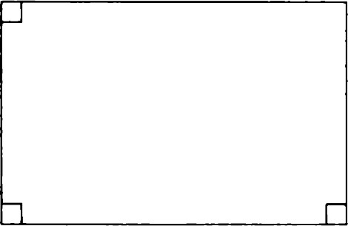

Figure 7.23 A Lambert quadrilateral.

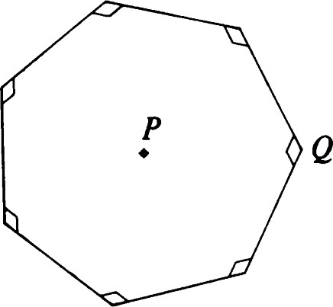

Figure 7.24 A regular 7-gon with seven right angles.

### 1 77

Proof: Let T be an isometry. We shall construct a sequence of reflections whose product coincides with T. First choose an arbitrary point P, and let Tl be the reflection that interchanges P and TP. Then TIT has P as a fixed point (Theorem 44). (In the special case where T already has a fixed point, we may shorten the construction by letting P be the fixed point and by letting Tl = 1.)

The second step is to construct T2, so that T2TIT fixes P and a line e through P. This may be arranged by letting T2 be a reflection interchanging an arbitrary line e through P with TITC (Theorem 45). (If TIT already has a fixed line e through P, we may choose T2 = I.)

Now, directly applying Theorem 46, we can choose a suitable reflection T3 (or possibly T3 = I), so that T3T2TIT leaves e pointwise fixed. Finally, by Theorem 47, we can choose T4 = oe or T4 = 1, so that T is the identity. Because each Ti is its own inverse, this means that T = T T T T as required.

Remark: As we saw in Theorem 35, this product may be written as the product of three or fewer reflections. In this case, however, we can observe this fact more directly as follows. Using Theorem 17, we can see that T2T3T4 is either a rotation about P or a reflection in a line through P. Then, depending on T1, we can conclude that T is a rotation, a reflection, or a glide reflection. Furthermore, we have all the information necessary to explicitly find the transformations T,.

Corollary. Every isometry of H2 is one of the following: reflection, rotation, parallel displacement, translation, or glide reflection.

#### Circles, horocycles, and equidistant curves

Definition. Let C be a point and r O a number. Then

C = {Xld(X, C) = r} (7.17) is called a circle with center C and radius r.

Theorem 49. Let be the pencil of lines through a point C, and let P be any point. Then the orbit of P by REF(") is the circle with center C and radius r = d(P, C). Conversely, every circle arises in this way.

Definition. Let m be a line and r a positive number. The portion of

{Xld(X, m) - (7.18) lying in a half-plane determined by m is called an equidistant curve. The line  is also (by definition) an equidistant curve corresponding to r = 0.

Theorem 50. Let be the pencil of lines perpendicular to a line m, and let P be any point. Then the orbit of P by REF(9) is an equidistant curve. Conversely, every equidistant curve arises in this way.

Definition. Let be a pencil of parallels, and let P be any point. Then the orbit of P by REF(") is called a horocycle.

Remark: The horocycle may be thought of as a limiting case of a circle having its center "at infinity.'

Theorem 51. Let v be a nonzero vector in R3 , and let a be a number. If

{x H2 1b(v, x) - (7.19)

is nonempty, it is a circle, an equidistant curve, or a horocycle. Conversely, each circle, equidistant curve, and horocycle has an equation of this form.

A higher-dimensional version of the results of this section is found in [61.

### EXERCISES

1. Prove Theorem 2.
2. Find spacelike vectors and such that x is a nonzero lightlike vector, but b(E,
3. Verify that neither parallel nor ultraparallel lines intersect. (See the remark following Theorem 6.)
4. Verify the remarks following the definition of pencils.
5. i. Let =  1, 0) and =  2, 1). Find an orthonormal basis with as one element and a multiple of x as another.
   1. Let and be the respective unit normals of lines of H2 . If the lines intersect, find the point of intersection. If they are ultraparallel, find the common perpendicular.
6. i. Prove Theorem 9.
   1. Prove that d(C, m) = cosh -l lß, n)l, where e and m are lines with unit normals and T).
7. Complete the proof of Theorem 11 by showing that d(Q, R) d(P, R) + d(P, Q) implies that P lies between Q and R.
8. Prove Theorem 12.
9. Verify that Theorems 17 and 18 hold.
10. Prove Theorem 19.
11. Prove Theorem 20 and the remark following it.
12. Prove Theorem 21.
13. Prove Theorem 22.
14. Prove Theorem 23 and its corollary.
15. Prove Theorem 24.
16. Check that must have the form (1, r, —r) as indicated in Theorem 25.
17. Verify formula (7.7).
18. Prove Theorem 27.
19. i. Check that DIS(9) is a subgroup of REF(9).
    1. Show that if a is any line of the pencil 9, REF(9) = DIS(9) U {OaDlD e DIS(")}.
    2. Check that the mapping h -4 Dh is an isomorphism of R (the additive group of real numbers) onto DIS(").
20. Verify formula (7.9).
21. Prove Theorems 28 and 29.
22. Let e be the common perpendicular of an ultraparallel pencil 9.

i. Check that TRANS(C) is a subgroup of REF("). ii. Show that if a is any line of the pencil 9,

REF(") = TRANS(C) U {Oa 0 TIT e TRANS(C)}.

This means that TRANS(C) is a subgroup of index 2. One coset is TRANS(C), and the other is the set of reflections.

iii. Check that the mapping h -4 Th is an isomorphism of R onto TRANS(C).

1. If e, m, and are lines of a pencil, prove that OeOmO„ =
2. If HI, 1-12, and H3 are distinct half-turns, prove that

HlH2H3 * H3H2Hl.

1. If T TRANS(m) and e -L m, show that OCT = TOC. verify formula (7.10).
2. Using the matrix representation (7.10), show that a nontrivial glide reflection i. has no fixed points, ii. leaves fixed its axis and no other lines.
3. Prove that there is a unique reflection C)ßq interchanging any two lines  and q of a pencil of parallels (respectively, ultraparallels).
4. What is the square of a glide reflection in H2 ?
5. Describe the product of two glide reflections in H2 with perpendicular axes.
6. Let P and Q be points. Show that there is a unique translation taking
7. Show that two nontrivial rotations of H2 commute if and only if they have the same center.
8. Let P, Q, and R be three noncollinear points of H2 . Discuss the product of the half-turns Hp, HQ, and HR. Given a rotation, show that it can be expressed as the product of three half-turns.
9. Let -y be a line. Explain why no line can be both parallel to and perpendicular to -y. 34. Let v and w be nonproportional lightlike vectors. Prove that b(v, w)
10. Prove Theorem 34.
11. Let P, Q, and R be three points lying, respectively, on three members A, q, and of a pencil of parallels. If P and Q are interchanged by Oßq, and Q and R are interchanged by C)re, prove that
    1. P, Q, and R cannot be collinear. ii. Of t interchanges P and R.

(Notation is as in Exercise 27.)

1. Prove Theorem 36.
2. Fill in the missing details in the proof of Theorem 38.
3. Prove Theorem 39.
4. Prove that a segment AB consists of A, B and all points between A and B.
5. Verify the statements made in the text about the definition of radian measure of an angle.
6. Prove Theorem 40.
7. Prove the crossbar theorem in H2
8. Prove the identity (7.12) for a e [—1, Il and X, e (O, 00).
9. Prove the formulas of hyperbolic trigonometry (Theorem 43).
10. Let ABC be a triangle in H2 with sides of lengths a = d(B, C), b — d(A, C), and c = d(A, B). Prove that if AC is perpendicular to AB, then cosh a = cosh b cosh c.

Find a direct proof that does not make use of Exercise 45.

1. The angle sum for a triangle in H2 is less than T. Prove this for the special cases of an equilateral triangle and a right-angled triangle.
2. The defect of a triangle in H2 is the amount by which its angle sum differs from IT. Let A ABC be a triangle, and let F be a point between A and C that is the foot of the perpendicular from B to AC. Prove that

defect(AABF) + defect(ACBF) = defect(AABC).

Hence, prove that the defect of any triangle in H2 is positive.

Remark: The analogous conclusion can be drawn in spherical geometry or elliptic geometry. The angle sum is greater than T, and the amount of the difference is called the excess. Defect and excess can be used as measures of area in non-Euclidean geometry. The excess cannot be greater than 2«, and in fact there are spherical triangles whose areas are as close to 2n as we please. On the other hand, the defect of a triangle in H2 is less than q, and there are triangles whose areas are as close to IT as we please.

1. Draw some pictures indicating how four points ABCD might not determine a convex quadrilateral.
2. Show that a Saccheri quadrilateral can be decomposed into two Lambert quadrilaterals.
3. Fill in the missing details in the proof of Theorem 44.
4. Verify that the reflection Oa in Theorem 45 interchanges the two given lines.
5. i. Prove that there is a unique reflection interchanging any two distinct rays with common origin.

ii. Prove that there are exactly two reflections interchanging two intersecting lines.

1. Let AB, BC, and CD be three line segments with AB i BC and BC i CD. Given that AB and CD have equal length, prove that d(A, C) = d(B, D). Work in H2 , although your results should be equally valid in E2 .
2. Find the symmetry group of
   1. the rhombus, ii. the equiangular quadrilateral, iii. the equiangular rhombus, iv. the Saccheri quadrilateral.
3. Formulate Hjelmslev's theorem so that it makes sense in H2 . Is it true ?
4. Verify that the SSS, SAS, and AAA congruence theorems hold in H2
5. What congruence theorems hold for asymptotic triangles?
6. Verify that the concurrence theorems (4.53 and 4.54) are valid in the hyperbolic plane.
7. Let PQ and PX be perpendicular segments. Show that there is a unique ray Q Y such that PQ, PX, and Q Y form an asymptotic triangle. If the radian measure of 4 Q is 0 and the length of PQ is d,

show that sin 0 cosh d = 1. The number 0 is called the "angle of parallelism" determined by d. See Figure 7.25.

1. Prove Theorem 49.
2. Prove that a circle has only one center and one radius.
3. 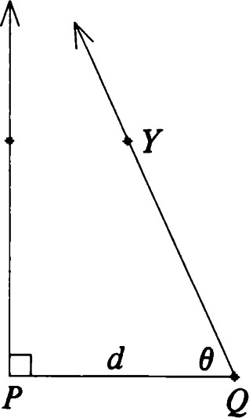Discuss the various ways in which a circle can intersect a line or another circle.
4. Prove Theorem 50.
5. Prove that an equidistant curve uniquely determines the line m and x the number r in (7.18).
6. Prove that a line meets an equidistant curve in at most two points.
7. Prove that a line meets a horocycle in at most two points.
8. Prove Theorem 51.
9. Identify the following curves in H2 .

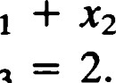= Sinh (2). Figure 7.25 The angle of parallelism. ii. x3 iii. Xl + x3

1. Prove that the groups ROT("), TRANS(m), and DIS(") would have worked equally well in characterizing circles, equidistant curves, and horocycles, respectively. What are the stabilizers in these cases?
2. Investigate the status of Theorems 49—50 and Exercises 61 —66 in the Euclidean, spherical, and projective settings.
3. Investigate the relationships suggested in the remark following Theorem 43.